k8s 1.29.0 集群+java 项目+HPA 部署+可视化监控

使用kubeadm部署Kubernetes 1.29
kubeadm是Kubernetes官方提供的用于快速安部署Kubernetes集群的工具。伴随Kubernetes每个版本的发布，kubeadm可能会对集群配置方面的一些实践做调整，通过实验kubeadm可以学习到Kubernetes官方在集群配置上一些新的最佳实践。

1.准备

1.1 系统配置
在安装之前，需要先做好如下准备。
3台Linux主机如下：
10.0.100.11 Ubuntu 20.04.6 LTS
10.0.100.12 Ubuntu 20.04.6 LTS
10.0.100.13 Ubuntu 20.04.6 LTS
在各个主机上完成下面的系统配置。
修改主机名（在 3 台服务器分别执行，第一台作为 master 节点）：
hostnamectl set-hostname master01
hostnamectl set-hostname node01
hostnamectl set-hostname node02
cat /etc/hosts
10.0.100.11 master01
10.0.100.12 node01
10.0.100.13 node02
如果系统启用了selinux，使用下面的命令禁用selinux:
setenforce 0
vi /etc/selinux/config
SELINUX=disabled
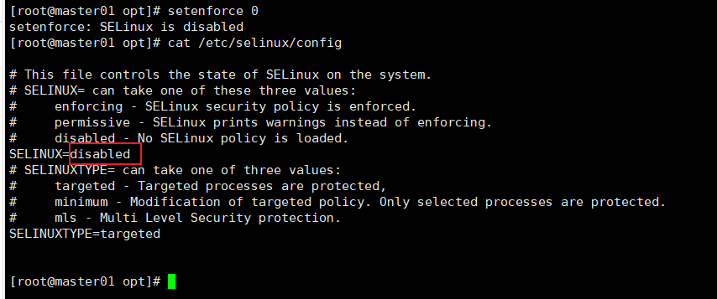
如果各个主机启用了防火墙策略，需要开放Kubernetes各个组件所需要的端口，可以查看Ports and Protocols中的内容, 开放相关端口或者关闭主机的防火墙。
创建/etc/modules-load.d/containerd.conf配置文件，确保在系统启动时自动加载所需的内核模块，以满足容器运行时的要求:
cat << EOF > /etc/modules-load.d/containerd.conf
overlay
br_netfilter
EOF
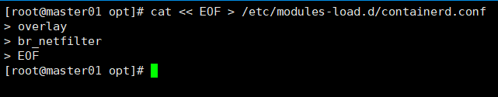
执行以下命令使配置生效:
modprobe overlay
modprobe br_netfilter
创建/etc/sysctl.d/99-kubernetes-cri.conf配置文件：
cat << EOF > /etc/sysctl.d/99-kubernetes-cri.conf
net.bridge.bridge-nf-call-ip6tables = 1
net.bridge.bridge-nf-call-iptables = 1
net.ipv4.ip_forward = 1
user.max_user_namespaces=28633
EOF
执行以下命令使配置生效:
sysctl -p /etc/sysctl.d/99-kubernetes-cri.conf
在文件名/etc/sysctl.d/99-kubernetes-cri.conf中，“99” 代表文件的优先级或顺序。sysctl是Linux内核参数的配置工具，它可以通过修改/proc/sys/目录下的文件来设置内核参数。在/etc/sysctl.d/目录中，可以放置一系列的配置文件，以便在系统启动时自动加载这些参数。这些配置文件按照文件名的字母顺序逐个加载。数字前缀用于指定加载的顺序，较小的数字表示较高的优先级。
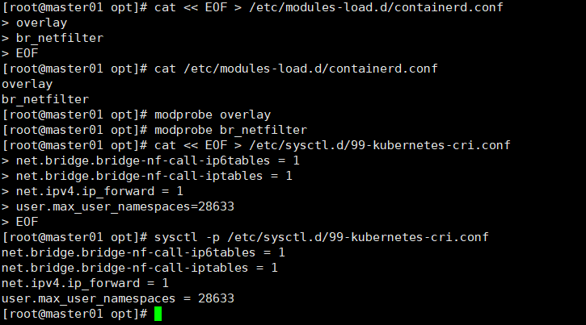

1.2 配置服务器支持开启ipvs的前提条件
由于ipvs已经加入到了内核的主干，所以为kube-proxy开启ipvs的前提需要加载以下的内核模块：
ip_vs
ip_vs_rr
ip_vs_wrr
ip_vs_sh
nf_conntrack_ipv4
创建/etc/modules-load.d/ipvs.conf文件，保证在节点重启后能自动加载所需模块:
cat > /etc/modules-load.d/ipvs.conf <<EOF
ip_vs
ip_vs_rr
ip_vs_wrr
ip_vs_sh
EOF
执行以下命令使配置立即生效:
modprobe ip_vs
modprobe ip_vs_rr
modprobe ip_vs_wrr
modprobe ip_vs_sh
使用lsmod | grep -e ip_vs -e nf_conntrack命令查看是否已经正确加载所需的内核模块。
接下来还需要确保各个节点上已经安装了ipset软件包，为了便于查看ipvs的代理规则，最好安装一下管理工具ipvsadm。
apt install -y ipset ipvsadm
如果不满足以上前提条件，即使kube-proxy的配置开启了ipvs模式，也会退回到iptables模式。
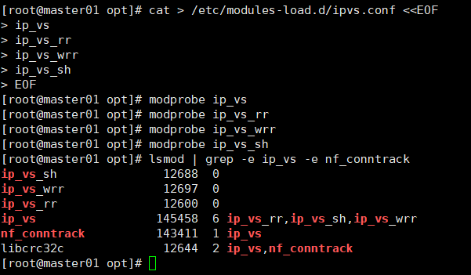

1.3 部署容器运行时Containerd
在各个服务器节点上安装容器运行时Containerd。
下载Containerd的二进制包， 需要注意cri-containerd-(cni-)-VERSION-OS-ARCH.tar.gz发行包自containerd 1.6版本起已经被弃用，在某些 Linux 发行版上无法正常工作，并将在containerd 2.0版本中移除，这里下载containerd-<VERSION>-<OS>-<ARCH>.tar.gz的发行包，后边再单独下载安装runc和CNI plugins:
wget https://github.com/containerd/containerd/releases/download/v1.7.11/containerd-1.7.11-linux-amd64.tar.gz
将其解压缩到/usr/local下:
tar Cxzvf /usr/local containerd-1.7.11-linux-amd64.tar.gz
bin/
bin/containerd-shim-runc-v2
bin/ctr
bin/containerd-shim
bin/containerd-shim-runc-v1
bin/containerd-stress
bin/containerd
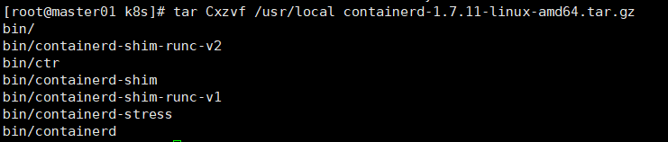
接下来从runc的github上单独下载安装runc，该二进制文件是静态构建的，并且应该适用于任何Linux发行版。
wget https://github.com/opencontainers/runc/releases/download/v1.1.9/runc.amd64
install -m 755 runc.amd64 /usr/local/sbin/runc
接下来生成containerd的配置文件:
mkdir -p /etc/containerd
containerd config default > /etc/containerd/config.toml
根据文档Container runtimes中的内容，对于使用systemd作为init system的Linux的发行版，使用systemd作为容器的cgroup driver可以确保服务器节点在资源紧张的情况更加稳定，因此这里配置各个节点上containerd的cgroup driver为systemd。
修改前面生成的配置文件/etc/containerd/config.toml：
[plugins."io.containerd.grpc.v1.cri".containerd.runtimes.runc]
...
[plugins."io.containerd.grpc.v1.cri".containerd.runtimes.runc.options]
SystemdCgroup = true
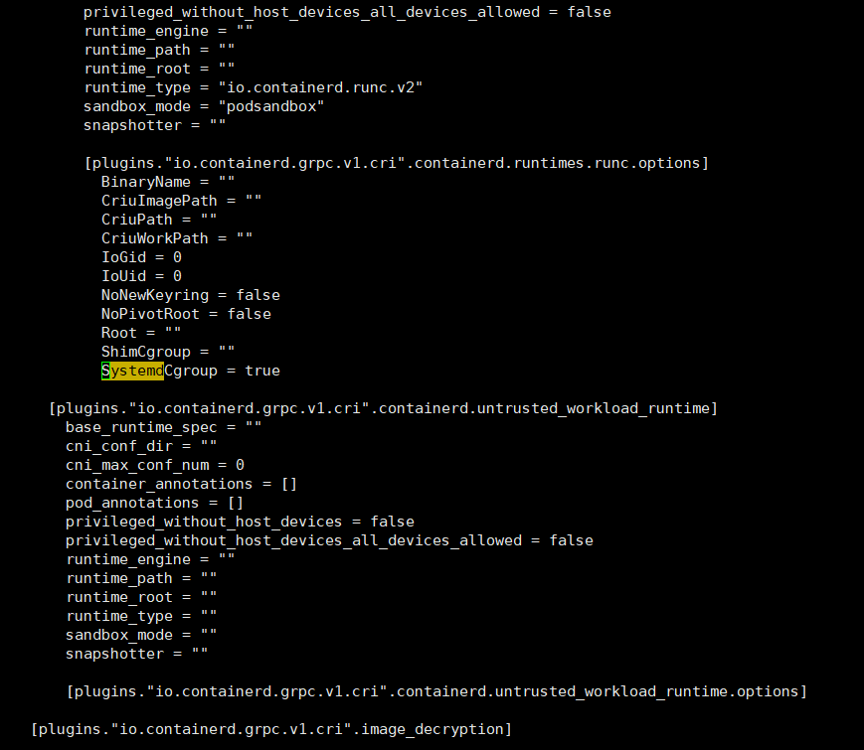
再修改/etc/containerd/config.toml中的
[plugins."io.containerd.grpc.v1.cri"]
...
# sandbox_image = "registry.k8s.io/pause:3.8"
sandbox_image = "registry.aliyuncs.com/google_containers/pause:3.9"
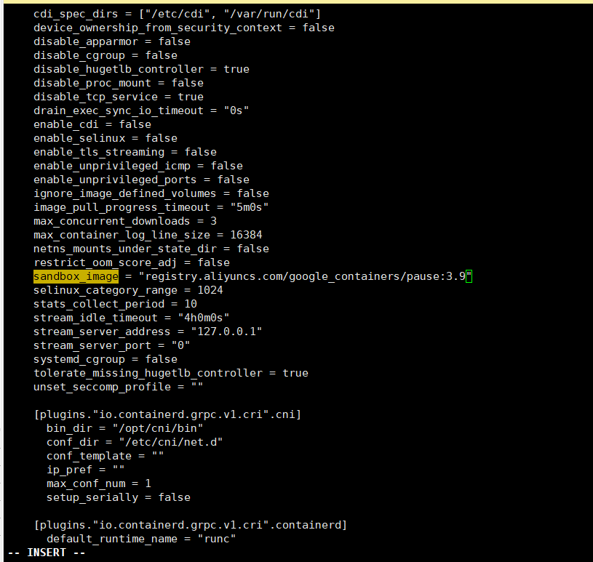
为了通过systemd启动containerd，请还需要从https://raw.githubusercontent.com/containerd/containerd/main/containerd.service下载containerd.service单元文件，并将其放置在 /etc/systemd/system/containerd.service中。
cat << EOF > /etc/systemd/system/containerd.service
[Unit]
Description=containerd container runtime
Documentation=https://containerd.io
After=network.target local-fs.target
[Service]
ExecStartPre=-/sbin/modprobe overlay
ExecStart=/usr/local/bin/containerd
Type=notify
Delegate=yes
KillMode=process
Restart=always
RestartSec=5
# Having non-zero Limit*s causes performance problems due to accounting overhead
# in the kernel. We recommend using cgroups to do container-local accounting.
LimitNPROC=infinity
LimitCORE=infinity
# Comment TasksMax if your systemd version does not supports it.
# Only systemd 226 and above support this version.
TasksMax=infinity
OOMScoreAdjust=-999
[Install]
WantedBy=multi-user.target
EOF
配置containerd开机启动，并启动containerd，执行以下命令:
systemctl daemon-reload
systemctl enable containerd --now
systemctl status containerd
下载安装crictl工具:
wget https://github.com/kubernetes-sigs/cri-tools/releases/download/v1.29.0/crictl-v1.29.0-linux-amd64.tar.gz
tar -zxvf crictl-v1.29.0-linux-amd64.tar.gz
install -m 755 crictl /usr/local/bin/crictl
使用crictl测试一下，确保可以打印出版本信息并且没有错误信息输出:
crictl --runtime-endpoint=unix:///run/containerd/containerd.sock version
Version: 0.1.0
RuntimeName: containerd
RuntimeVersion: v1.7.11
RuntimeApiVersion: v1
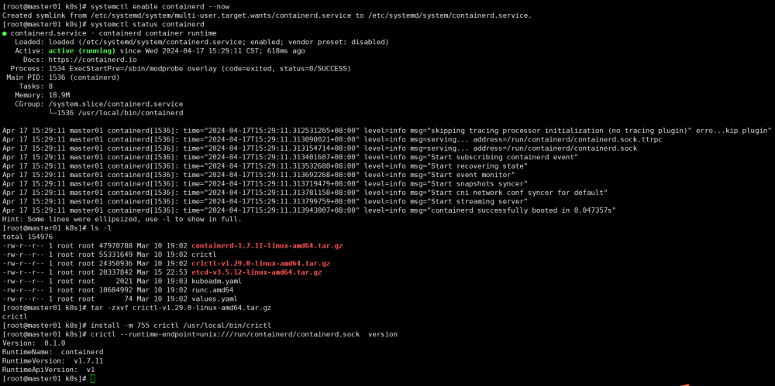

2.使用kubeadm部署Kubernetes

2.1 安装kubeadm和kubelet
# 此操作会覆盖 /etc/apt.repos.d/kubernetes.repo 中现存的所有配置
cat <<EOF | sudo tee /etc/apt.repos.d/kubernetes.repo
[kubernetes]
name=Kubernetes
baseurl=https://pkgs.k8s.io/core:/stable:/v1.29/rpm/
enabled=1
gpgcheck=1
gpgkey=https://pkgs.k8s.io/core:/stable:/v1.29/rpm/repodata/repomd.xml.key
exclude=kubelet kubeadm kubectl cri-tools kubernetes-cni
EOF
安装 kubelet、kubeadm 和 kubectl，并启用 kubelet 以确保它在启动时自动启动:
apt install -y kubelet kubeadm kubectl --disableexcludes=kubernetes
systemctl enable --now kubelet

2.2 使用kubeadm init初始化集群
在各节点开机启动kubelet服务：
systemctl enable kubelet.service
使用kubeadm config print init-defaults --component-configs KubeletConfiguration可以打印集群初始化默认的使用的配置：
apiVersion: kubeadm.k8s.io/v1beta3
bootstrapTokens:
- groups:
- system:bootstrappers:kubeadm:default-node-token
token: abcdef.0123456789abcdef
ttl: 24h0m0s
usages:
- signing
- authentication
kind: InitConfiguration
localAPIEndpoint:
advertiseAddress: 1.2.3.4
bindPort: 6443
nodeRegistration:
criSocket: unix:///var/run/containerd/containerd.sock
imagePullPolicy: IfNotPresent
name: node
taints: null
---
apiServer:
timeoutForControlPlane: 4m0s
apiVersion: kubeadm.k8s.io/v1beta3
certificatesDir: /etc/kubernetes/pki
clusterName: kubernetes
controllerManager: {}
dns: {}
etcd:
local:
dataDir: /var/lib/etcd
imageRepository: registry.k8s.io
kind: ClusterConfiguration
kubernetesVersion: 1.29.0
networking:
dnsDomain: cluster.local
serviceSubnet: 10.96.0.0/12
scheduler: {}
---
apiVersion: kubelet.config.k8s.io/v1beta1
authentication:
anonymous:
enabled: false
webhook:
cacheTTL: 0s
enabled: true
x509:
clientCAFile: /etc/kubernetes/pki/ca.crt
authorization:
mode: Webhook
webhook:
cacheAuthorizedTTL: 0s
cacheUnauthorizedTTL: 0s
cgroupDriver: systemd
clusterDNS:
- 10.96.0.10
clusterDomain: cluster.local
containerRuntimeEndpoint: ""
cpuManagerReconcilePeriod: 0s
evictionPressureTransitionPeriod: 0s
fileCheckFrequency: 0s
healthzBindAddress: 127.0.0.1
healthzPort: 10248
httpCheckFrequency: 0s
imageMaximumGCAge: 0s
imageMinimumGCAge: 0s
kind: KubeletConfiguration
logging:
flushFrequency: 0
options:
json:
infoBufferSize: "0"
verbosity: 0
memorySwap: {}
nodeStatusReportFrequency: 0s
nodeStatusUpdateFrequency: 0s
resolvConf: /run/systemd/resolve/resolv.conf
rotateCertificates: true
runtimeRequestTimeout: 0s
shutdownGracePeriod: 0s
shutdownGracePeriodCriticalPods: 0s
staticPodPath: /etc/kubernetes/manifests
streamingConnectionIdleTimeout: 0s
syncFrequency: 0s
volumeStatsAggPeriod: 0s
从默认的配置中可以看到，可以使用imageRepository定制在集群初始化时拉取k8s所需镜像的地址。基于默认配置定制出本次使用kubeadm初始化集群所需的配置文件kubeadm.yaml：
apiVersion: kubeadm.k8s.io/v1beta3
kind: InitConfiguration
localAPIEndpoint:
advertiseAddress: 10.0.100.11
bindPort: 6443
nodeRegistration:
criSocket: unix:///run/containerd/containerd.sock
taints:
- effect: PreferNoSchedule
key: node-role.kubernetes.io/master
---
apiVersion: kubeadm.k8s.io/v1beta3
kind: ClusterConfiguration
kubernetesVersion: 1.29.0
imageRepository: registry.aliyuncs.com/google_containers
networking:
podSubnet: 10.244.0.0/16
---
apiVersion: kubelet.config.k8s.io/v1beta1
kind: KubeletConfiguration
cgroupDriver: systemd
failSwapOn: false
---
apiVersion: kubeproxy.config.k8s.io/v1alpha1
kind: KubeProxyConfiguration
mode: ipvs
这里定制了imageRepository为阿里云的registry，避免因gcr被墙，无法直接拉取镜像。criSocket设置了容器运行时为containerd。 同时设置kubelet的cgroupDriver为systemd，设置kube-proxy代理模式为ipvs。
在开始初始化集群之前可以使用kubeadm config images pull --config kubeadm.yaml预先在各个服务器节点上拉取所k8s需要的容器镜像。
kubeadm config images list --config kubeadm.yaml
registry.aliyuncs.com/google_containers/kube-apiserver:v1.29.0
registry.aliyuncs.com/google_containers/kube-controller-manager:v1.29.0
registry.aliyuncs.com/google_containers/kube-scheduler:v1.29.0
registry.aliyuncs.com/google_containers/kube-proxy:v1.29.0
registry.aliyuncs.com/google_containers/coredns:v1.11.1
registry.aliyuncs.com/google_containers/pause:3.9
registry.aliyuncs.com/google_containers/etcd:3.5.10-0
kubeadm config images pull --config kubeadm.yaml
[config/images] Pulled registry.aliyuncs.com/google_containers/kube-apiserver:v1.29.0
[config/images] Pulled registry.aliyuncs.com/google_containers/kube-controller-manager:v1.29.0
[config/images] Pulled registry.aliyuncs.com/google_containers/kube-scheduler:v1.29.0
[config/images] Pulled registry.aliyuncs.com/google_containers/kube-proxy:v1.29.0
[config/images] Pulled registry.aliyuncs.com/google_containers/coredns:v1.11.1
[config/images] Pulled registry.aliyuncs.com/google_containers/pause:3.9
[config/images] Pulled registry.aliyuncs.com/google_containers/etcd:3.5.10-0
接下来使用kubeadm初始化集群，在 master01 上执行下面的命令：
[root@master01 k8s]# kubeadm init --config kubeadm.yaml
[init] Using Kubernetes version: v1.29.0
[preflight] Running pre-flight checks
[preflight] Pulling images required for setting up a Kubernetes cluster
[preflight] This might take a minute or two, depending on the speed of your internet connection
[preflight] You can also perform this action in beforehand using 'kubeadm config images pull'
[certs] Using certificateDir folder "/etc/kubernetes/pki"
[certs] Generating "ca" certificate and key
[certs] Generating "apiserver" certificate and key
[certs] apiserver serving cert is signed for DNS names [kubernetes kubernetes.default kubernetes.default.svc kubernetes.default.svc.cluster.local node] and IPs [10.96.0.1 172.22.55.94]
[certs] Generating "apiserver-kubelet-client" certificate and key
[certs] Generating "front-proxy-ca" certificate and key
[certs] Generating "front-proxy-client" certificate and key
[certs] Generating "etcd/ca" certificate and key
[certs] Generating "etcd/server" certificate and key
[certs] etcd/server serving cert is signed for DNS names [localhost node] and IPs [172.22.55.94 127.0.0.1 ::1]
[certs] Generating "etcd/peer" certificate and key
[certs] etcd/peer serving cert is signed for DNS names [localhost node] and IPs [172.22.55.94 127.0.0.1 ::1]
[certs] Generating "etcd/healthcheck-client" certificate and key
[certs] Generating "apiserver-etcd-client" certificate and key
[certs] Generating "sa" key and public key
[kubeconfig] Using kubeconfig folder "/etc/kubernetes"
[kubeconfig] Writing "admin.conf" kubeconfig file
[kubeconfig] Writing "super-admin.conf" kubeconfig file
[kubeconfig] Writing "kubelet.conf" kubeconfig file
[kubeconfig] Writing "controller-manager.conf" kubeconfig file
[kubeconfig] Writing "scheduler.conf" kubeconfig file
[etcd] Creating static Pod manifest for local etcd in "/etc/kubernetes/manifests"
[control-plane] Using manifest folder "/etc/kubernetes/manifests"
[control-plane] Creating static Pod manifest for "kube-apiserver"
[control-plane] Creating static Pod manifest for "kube-controller-manager"
[control-plane] Creating static Pod manifest for "kube-scheduler"
[kubelet-start] Writing kubelet environment file with flags to file "/var/lib/kubelet/kubeadm-flags.env"
[kubelet-start] Writing kubelet configuration to file "/var/lib/kubelet/config.yaml"
[kubelet-start] Starting the kubelet
[wait-control-plane] Waiting for the kubelet to boot up the control plane as static Pods from directory "/etc/kubernetes/manifests". This can take up to 4m0s
[apiclient] All control plane components are healthy after 7.504168 seconds
[upload-config] Storing the configuration used in ConfigMap "kubeadm-config" in the "kube-system" Namespace
[kubelet] Creating a ConfigMap "kubelet-config" in namespace kube-system with the configuration for the kubelets in the cluster
[upload-certs] Skipping phase. Please see --upload-certs
[mark-control-plane] Marking the node node as control-plane by adding the labels: [node-role.kubernetes.io/control-plane node.kubernetes.io/exclude-from-external-load-balancers]
[mark-control-plane] Marking the node node as control-plane by adding the taints [node-role.kubernetes.io/control-plane:NoSchedule]
[bootstrap-token] Using token: abcdef.0123456789abcdef
[bootstrap-token] Configuring bootstrap tokens, cluster-info ConfigMap, RBAC Roles
[bootstrap-token] Configured RBAC rules to allow Node Bootstrap tokens to get nodes
[bootstrap-token] Configured RBAC rules to allow Node Bootstrap tokens to post CSRs in order for nodes to get long term certificate credentials
[bootstrap-token] Configured RBAC rules to allow the csrapprover controller automatically approve CSRs from a Node Bootstrap Token
[bootstrap-token] Configured RBAC rules to allow certificate rotation for all node client certificates in the cluster
[bootstrap-token] Creating the "cluster-info" ConfigMap in the "kube-public" namespace
[kubelet-finalize] Updating "/etc/kubernetes/kubelet.conf" to point to a rotatable kubelet client certificate and key
[addons] Applied essential addon: CoreDNS
[addons] Applied essential addon: kube-proxy
Your Kubernetes control-plane has initialized successfully!
To start using your cluster, you need to run the following as a regular user:
mkdir -p $HOME/.kube
sudo cp -i /etc/kubernetes/admin.conf $HOME/.kube/config
sudo chown $(id -u):$(id -g) $HOME/.kube/config
Alternatively, if you are the root user, you can run:
export KUBECONFIG=/etc/kubernetes/admin.conf
You should now deploy a pod network to the cluster.
Run "kubectl apply -f [podnetwork].yaml" with one of the options listed at:
https://kubernetes.io/docs/concepts/cluster-administration/addons/
Then you can join any number of worker nodes by running the following on each as root:
kubeadm join 172.22.55.94:6443 --token abcdef.0123456789abcdef \
--discovery-token-ca-cert-hash sha256:2422d4710112a3ca605514d5ed05fa9fd1071a60fd2a1ff1d6c0e45b4a15e8c6
上面记录了完成的初始化输出的内容，根据输出的内容基本上可以看出手动初始化安装一个Kubernetes集群所需要的关键步骤。 其中有以下关键内容：
- [certs]生成相关的各种证书
- [kubeconfig]生成相关的kubeconfig文件
- [kubelet-start] 生成kubelet的配置文件"/var/lib/kubelet/config.yaml"
- [control-plane]使用/etc/kubernetes/manifests目录中的yaml文件创建apiserver、controller-manager、scheduler的静态pod
- [bootstraptoken]生成token记录下来，后边使用kubeadm join往集群中添加节点时会用到
- [addons]安装基本插件:CoreDNS, kube-proxy
- 下面的命令是配置常规用户如何使用kubectl访问集群：
mkdir -p $HOME/.kube
sudo cp -i /etc/kubernetes/admin.conf $HOME/.kube/config
sudo chown $(id -u):$(id -g) $HOME/.kube/config
- 最后给出了将另外2个节点加入集群的命令:
kubeadm join 10.0.100.11:6443 --token abcdef.0123456789abcdef \
--discovery-token-ca-cert-hash sha256:2422d4710112a3ca605514d5ed05fa9fd1071a60fd2a1ff1d6c0e45b4a15e8c6
查看一下集群状态，确认个组件都处于healthy状态:
kubectl get cs
Warning: v1 ComponentStatus is deprecated in v1.19+
NAME STATUS MESSAGE ERROR
controller-manager Healthy ok
scheduler Healthy ok
etcd-0 Healthy ok
集群初始化如果遇到问题，可以使用kubeadm reset命令进行清理。

2.3 安装包管理器helm 3
Helm是Kubernetes的包管理器，后续流程也将使用Helm安装Kubernetes的常用组件。 这里先在master节点node4上安装helm。
wget https://get.helm.sh/helm-v3.13.3-linux-amd64.tar.gz
tar -zxvf helm-v3.13.3-linux-amd64.tar.gz
install -m 755 linux-amd64/helm /usr/local/bin/helm
执行helm list确认没有错误输出。

2.4 部署Pod Network组件Calico
选择calico作为k8s的Pod网络组件，下面使用helm在k8s集群中安装calico。
下载tigera-operator的helm chart:
wget https://github.com/projectcalico/calico/releases/download/v3.27.0/tigera-operator-v3.27.0.tgz
查看这个chart的中可定制的配置:
helm show values tigera-operator-v3.27.0.tgz
# imagePullSecrets is a special helm field which, when specified, creates a secret
# containing the pull secret which is used to pull all images deployed by this helm chart and the resulting operator.
# this field is a map where the key is the desired secret name and the value is the contents of the imagePullSecret.
#
# Example: --set-file imagePullSecrets.gcr=./pull-secret.json
imagePullSecrets: {}
installation:
enabled: true
kubernetesProvider: ""
# imagePullSecrets are configured on all images deployed by the tigera-operator.
# secrets specified here must exist in the tigera-operator namespace; they won't be created by the operator or helm.
# imagePullSecrets are a slice of LocalObjectReferences, which is the same format they appear as on deployments.
#
# Example: --set installation.imagePullSecrets[0].name=my-existing-secret
imagePullSecrets: []
apiServer:
enabled: true
certs:
node:
key:
cert:
commonName:
typha:
key:
cert:
commonName:
caBundle:
# Resource requests and limits for the tigera/operator pod.
resources: {}
# Tolerations for the tigera/operator pod.
tolerations:
- effect: NoExecute
operator: Exists
- effect: NoSchedule
operator: Exists
# NodeSelector for the tigera/operator pod.
nodeSelector:
kubernetes.io/os: linux
# Custom annotations for the tigera/operator pod.
podAnnotations: {}
# Custom labels for the tigera/operator pod.
podLabels: {}
# Image and registry configuration for the tigera/operator pod.
tigeraOperator:
image: tigera/operator
version: v1.32.3
registry: quay.io
calicoctl:
image: docker.io/calico/ctl
tag: v3.27.0
kubeletVolumePluginPath: /var/lib/kubelet
定制的values.yaml如下:
# 可针对上面的配置进行定制,例如calico的镜像改成从私有库拉取。
# 这里只是个人本地环境测试k8s新版本，因此只有下面几行配置
apiServer:
enabled: false
installation:
kubeletVolumePluginPath: None
使用helm安装calico：
helm install calico tigera-operator-v3.27.0.tgz -n kube-system --create-namespace -f values.yaml
等待并确认所有pod处于Running状态:
kubectl get pod -n kube-system | grep tigera-operator
tigera-operator-55585899bf-qkr84 1/1 Running 0 26s
kubectl get pods -n calico-system
NAME READY STATUS RESTARTS AGE
calico-kube-controllers-6784546df7-5dzld 1/1 Running 0 5m30s
calico-node-24px9 1/1 Running 0 5m30s
calico-typha-75854bc9c9-5zvrb 1/1 Running 0 5m31s
csi-node-driver-mttxs 2/2 Running 0 5m30s
查看一下calico向k8s中添加的api资源:
kubectl api-resources | grep calico
bgpconfigurations crd.projectcalico.org/v1 false BGPConfiguration
bgpfilters crd.projectcalico.org/v1 false BGPFilter
bgppeers crd.projectcalico.org/v1 false BGPPeer
blockaffinities crd.projectcalico.org/v1 false BlockAffinity
caliconodestatuses crd.projectcalico.org/v1 false CalicoNodeStatus
clusterinformations crd.projectcalico.org/v1 false ClusterInformation
felixconfigurations crd.projectcalico.org/v1 false FelixConfiguration
globalnetworkpolicies crd.projectcalico.org/v1 false GlobalNetworkPolicy
globalnetworksets crd.projectcalico.org/v1 false GlobalNetworkSet
hostendpoints crd.projectcalico.org/v1 false HostEndpoint
ipamblocks crd.projectcalico.org/v1 false IPAMBlock
ipamconfigs crd.projectcalico.org/v1 false IPAMConfig
ipamhandles crd.projectcalico.org/v1 false IPAMHandle
ippools crd.projectcalico.org/v1 false IPPool
ipreservations crd.projectcalico.org/v1 false IPReservation
kubecontrollersconfigurations crd.projectcalico.org/v1 false KubeControllersConfiguration
networkpolicies crd.projectcalico.org/v1 true NetworkPolicy
networksets crd.projectcalico.org/v1 true NetworkSet
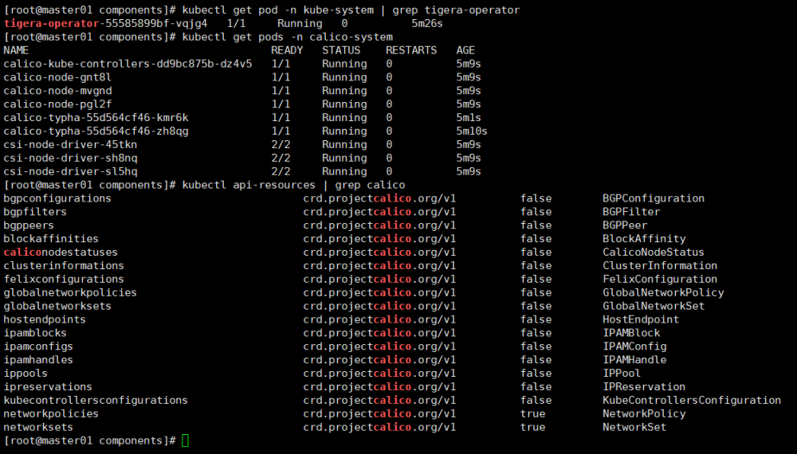
这些api资源是属于calico的，因此不建议使用kubectl来管理，推荐按照calicoctl来管理这些api资源。 将calicoctl安装为kubectl的插件:
cd /usr/local/bin
curl -o kubectl-calico -O -L "https://github.com/projectcalico/calico/releases/download/v3.27.0/calicoctl-linux-amd64"
chmod +x kubectl-calico
验证插件正常工作:
kubectl calico -h

2.5 验证k8s DNS是否可用
kubectl run curl --image=radial/busyboxplus:curl -it
If you don't see a command prompt, try pressing enter.
[ root@curl:/ ]$
进入后执行nslookup kubernetes.default确认解析正常:
nslookup kubernetes.default
Server: 10.96.0.10
Address 1: 10.96.0.10 kube-dns.kube-system.svc.cluster.local
Name: kubernetes.default
Address 1: 10.96.0.1 kubernetes.default.svc.cluster.local
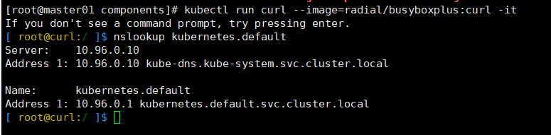

2.6 向Kubernetes集群中添加Node节点
下面将node5, node6添加到Kubernetes集群中，分别在node5, node6上执行:
kubeadm join 10.0.100.11:6443 --token abcdef.0123456789abcdef \
--discovery-token-ca-cert-hash sha256:2422d4710112a3ca605514d5ed05fa9fd1071a60fd2a1ff1d6c0e45b4a15e8c6
之后3个节点上的calico相关pod全部启动正常:
kubectl get po -n calico-system -o wide
NAME READY STATUS RESTARTS AGE IP NODE NOMINATED NODE READINESS GATES
calico-kube-controllers-6784546df7-5dzld 1/1 Running 0 20m 10.244.3.67 node4 <none> <none>
calico-node-24px9 1/1 Running 0 20m 192.168.96.154 node4 <none> <none>
calico-node-ht7cf 1/1 Running 0 7m6s 192.168.96.155 node5 <none> <none>
calico-node-tzql5 1/1 Running 0 7m4s 192.168.96.156 node6 <none> <none>
calico-typha-75854bc9c9-5zvrb 1/1 Running 0 20m 192.168.96.154 node4 <none> <none>
calico-typha-75854bc9c9-l8bmh 1/1 Running 0 6m56s 192.168.96.155 node5 <none> <none>
csi-node-driver-2mk5s 2/2 Running 0 7m6s 10.244.33.129 node5 <none> <none>
csi-node-driver-9qrzx 2/2 Running 0 7m4s 10.244.139.1 node6 <none> <none>
csi-node-driver-mttxs 2/2 Running 0 20m 10.244.3.65 node4 <none> <none>
在master节点上执行命令查看集群中的节点(需要等待新加入节点上的calico-node pod启动正常)：
kubectl get node
NAME STATUS ROLES AGE VERSION
node4 Ready control-plane 34m v1.29.0
node5 Ready <none> 7m31s v1.29.0
node6 Ready <none> 7m29s v1.29.0
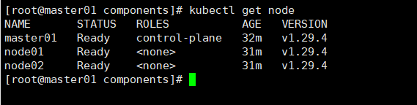

3.Kubernetes 常用组件部署

3.1 使用Helm部署ingress-nginx
为了便于将集群中的服务暴露到集群外部，需要使用Ingress。接下来使用Helm将ingress-nginx部署到Kubernetes上。 Nginx Ingress Controller被部署在Kubernetes的边缘节点上。
这里将node4(192.168.96.154)作为边缘节点，打上Label：
kubectl label node node4 node-role.kubernetes.io/edge=
下载ingress-nginx的helm chart:
wget https://github.com/kubernetes/ingress-nginx/releases/download/helm-chart-4.9.0/ingress-nginx-4.9.0.tgz
查看ingress-nginx-4.9.0.tgz这个chart的可定制配置:
helm show values ingress-nginx-4.9.0.tgz
对values.yaml配置定制如下:
controller:
ingressClassResource:
name: nginx
enabled: true
default: true
controllerValue: "k8s.io/ingress-nginx"
admissionWebhooks:
enabled: false
replicaCount: 1
image:
# registry: registry.k8s.io
# image: ingress-nginx/controller
# tag: "v1.9.5"
registry: docker.io
image: unreachableg/registry.k8s.io_ingress-nginx_controller
tag: "v1.9.5"
digest: sha256:bdc54c3e73dcec374857456559ae5757e8920174483882b9e8ff1a9052f96a35
hostNetwork: true
nodeSelector:
node-role.kubernetes.io/edge: ''
affinity:
podAntiAffinity:
requiredDuringSchedulingIgnoredDuringExecution:
- labelSelector:
matchExpressions:
- key: app
operator: In
values:
- nginx-ingress
- key: component
operator: In
values:
- controller
topologyKey: kubernetes.io/hostname
tolerations:
- key: node-role.kubernetes.io/master
operator: Exists
effect: NoSchedule
- key: node-role.kubernetes.io/master
operator: Exists
effect: PreferNoSchedule
nginx ingress controller的副本数replicaCount为1，将被调度到node4这个边缘节点上。这里并没有指定nginx ingress controller service的externalIPs，而是通过hostNetwork: true设置nginx ingress controller使用宿主机网络。 因为registry.k8s.io被墙，这里替换成unreachableg/registry.k8s.io_ingress-nginx_controller提前拉取一下镜像:
crictl --runtime-endpoint=unix:///run/containerd/containerd.sock pull registry.lank8s.cn/ingress-nginx/controller:v1.10.0@sha256:42b3f0e5d0846876b1791cd3afeb5f1cbbe4259d6f35651dcc1b5c980925379c
helm install ingress-nginx ingress-nginx-4.10.0.tgz --create-namespace -n ingress-nginx -f values.yaml
kubectl get po -n ingress-nginx
NAME READY STATUS RESTARTS AGE
ingress-nginx-controller-6445445cb8-c4fh4 1/1 Running 0 74s

3.1 安装 metrics-server
kubectl apply -f https://github.com/kubernetes-sigs/metrics-server/releases/download/v0.7.0/components.yaml

3.1 配置 HPA
开启 - --enable-aggregator-routing=true 参数
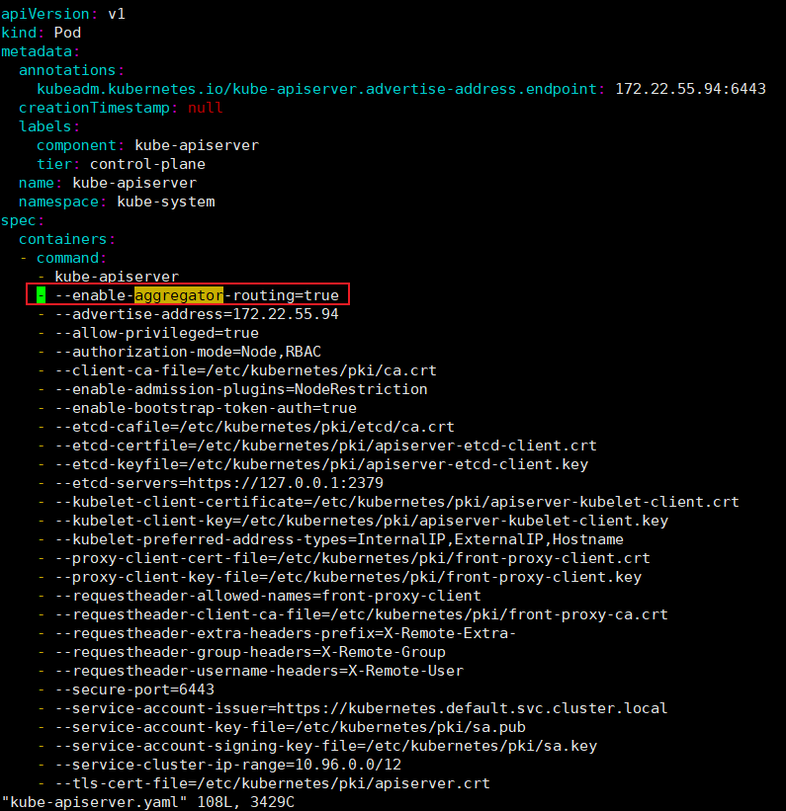

4.部署 java+mysql 美食站点项目
准备好打包好的镜像包
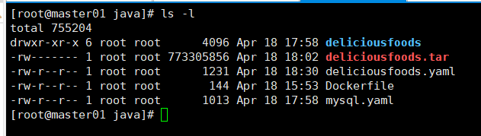
准备 mysql yaml
apiVersion: apps/v1
kind: Deployment
metadata:
name: mysql
spec:
replicas: 1
selector:
matchLabels:
app: mysql
template:
metadata:
labels:
app: mysql
spec:
nodeSelector:
kubernetes.io/hostname: node01
containers:
- name: mysql
image: mysql:5.7
ports:
- containerPort: 3306
env:
- name: MYSQL_ROOT_PASSWORD
value: rootpassword
- name: MYSQL_DATABASE
value: deliciousFoods
- name: MYSQL_USER
value: otherUser
- name: MYSQL_PASSWORD
value: password
volumeMounts:
- name: mysql-data
mountPath: /var/lib/mysql
volumes:
- name: mysql-data
hostPath:
path: /data/mysql # 本地磁盘路径，根据实际情况修改
---
apiVersion: v1
kind: Service
metadata:
name: mysql
spec:
selector:
app: mysql
ports:
- protocol: TCP
port: 3306
targetPort: 3306
type: NodePort
deliciousfoods 项目的 deliciousfoods.yaml 文件
apiVersion: apps/v1
kind: Deployment
metadata:
annotations:
deployment.kubernetes.io/revision: "1"
generation: 1
labels:
app: deliciousfoods
name: deliciousfoods
namespace: default
spec:
progressDeadlineSeconds: 600
replicas: 1
revisionHistoryLimit: 10
selector:
matchLabels:
app: deliciousfoods
strategy:
rollingUpdate:
maxSurge: 25%
maxUnavailable: 25%
type: RollingUpdate
template:
metadata:
creationTimestamp: null
labels:
app: deliciousfoods
spec:
containers:
- image: deliciousfoods:202404181708
imagePullPolicy: IfNotPresent
name: deliciousfoods
ports:
- containerPort: 8080
protocol: TCP
resources: {}
terminationMessagePath: /dev/termination-log
terminationMessagePolicy: File
resources:
requests:
memory: "64Mi"
cpu: "250m"
limits:
memory: "512Mi"
cpu: "500m"
dnsPolicy: ClusterFirst
restartPolicy: Always
schedulerName: default-scheduler
securityContext: {}
terminationGracePeriodSeconds: 30
---
apiVersion: v1
kind: Service
metadata:
name: deliciousfoods
spec:
type: NodePort
selector:
app: deliciousfoods
ports:
- protocol: TCP
port: 8080
targetPort: 8080
nodePort: 30000
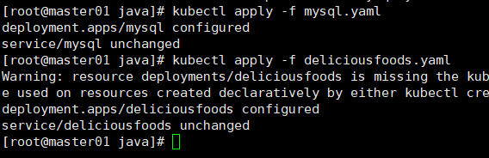
查看暴露的 nodeport 端口，直接在服务器请求，返程前端内容则显示部署成功
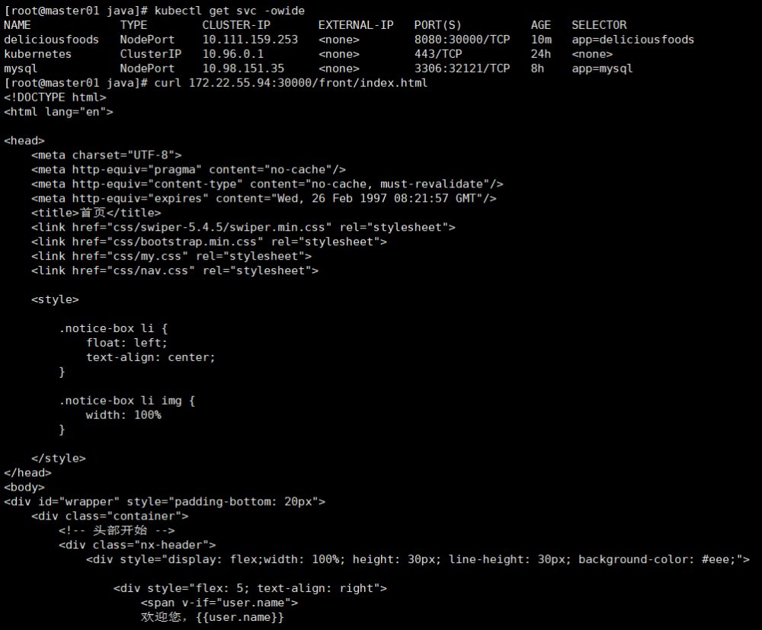
在外网访问地址：
http://10.0.100.11:30000/front/index.html


5.HPA 自动伸缩容演练
kubectl autoscale deployment deliciousfoods --cpu-percent=50 --min=1 --max=5
kubectl get hpa
增加负载
kubectl run -i --tty load-generator --rm --image=busybox:1.28 --restart=Never -- /bin/sh -c "while sleep 0.01; do wget -q -O- http://deliciousfoods:8080/front/index.html; done"
可以发现已经自动开始扩容
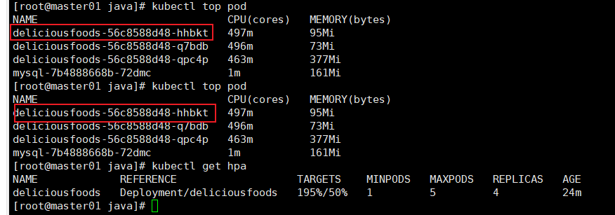

6.可视化监控
K8s本身不包含内置的监控工具，所以市场上有不少这样监控工具来填补这一空白，但是没有一个监控工具有prometheus全家桶使用率高，因为它由 CNCF维护，已经成为了监控 k8s 集群的事实上的行业标准，下面介绍一下如何在K8s快速部署一个kube-prometheus项目，来实现对k8s 相关资源监控与告警
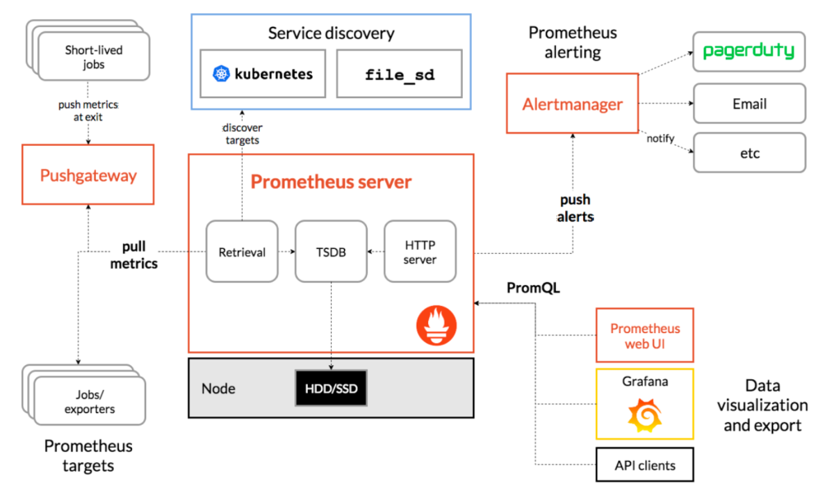
kube-prometheus是一个完整的监控解决方案，可以轻松地将其部署到 Kubernetes 集群中，它包括以下内容
Prometheus 用于度量收集
Alertmanager 用于指标警报和通知
Grafana 用于图形用户界面
一组特定于K8s的exporters，用作指标收集代理
使用 Prometheus Operator 来简化和自动化该堆栈的设置
快速安装
wget https://github.com/prometheus-operator/kube-prometheus/archive/refs/tags/v0.13.0.zip
tar -zxvf kube-prometheus-0.13.0.zip & cd kube-prometheus-0.13.0
kubectl apply --server-side -f manifests/setup
kubectl apply -f manifests/
kubectl get pods -n monitoring
执行完了以后，打开监控页面查看监控状态：
http://10.0.100.11:30300/
默认账号密码：admin/admin
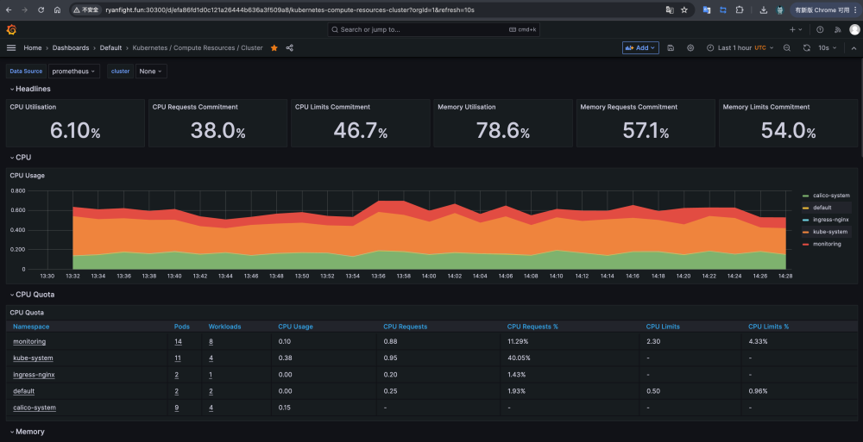
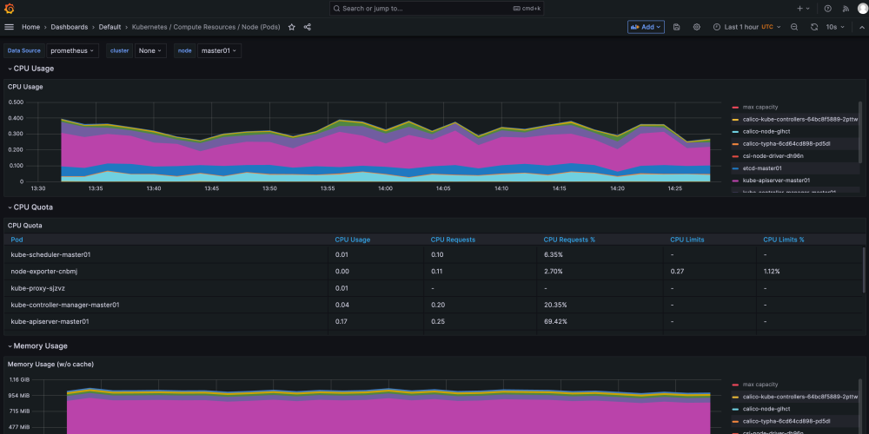
Grafana显示时间问题
由于grafana默认时区是UTC，比中国时间慢了8小时，很不便于日常监控查看，需要进行修改
sed -i 's/utc/utc+8/g' grafana-dashboardDefinitions.yaml
sed -i 's/UTC/UTC+8/g' grafana-dashboardDefinitions.yaml
grep -i timezone grafana-dashboardDefinitions.yaml
kubectl apply -f grafana-dashboardDefinitions.yaml

